# Output Notes.docx

# Lincoln

runMCMC terminated after 401.969999999987seconds

96000 . Current logp -870.8772 -862.1926 -865.5632 Please wait! runMCMC terminated after 406.360000000001seconds

96000 . Current logp -859.7052 -860.4851 -865.3595 Please wait! runMCMC terminated after 415.619999999995seconds

96000 . Current logp -860.5489 -872.4073 -865.9553 Please wait!

Total chains = 9

Total samples per chain = 16000

Overall convergence (mpsrf) = 1.687

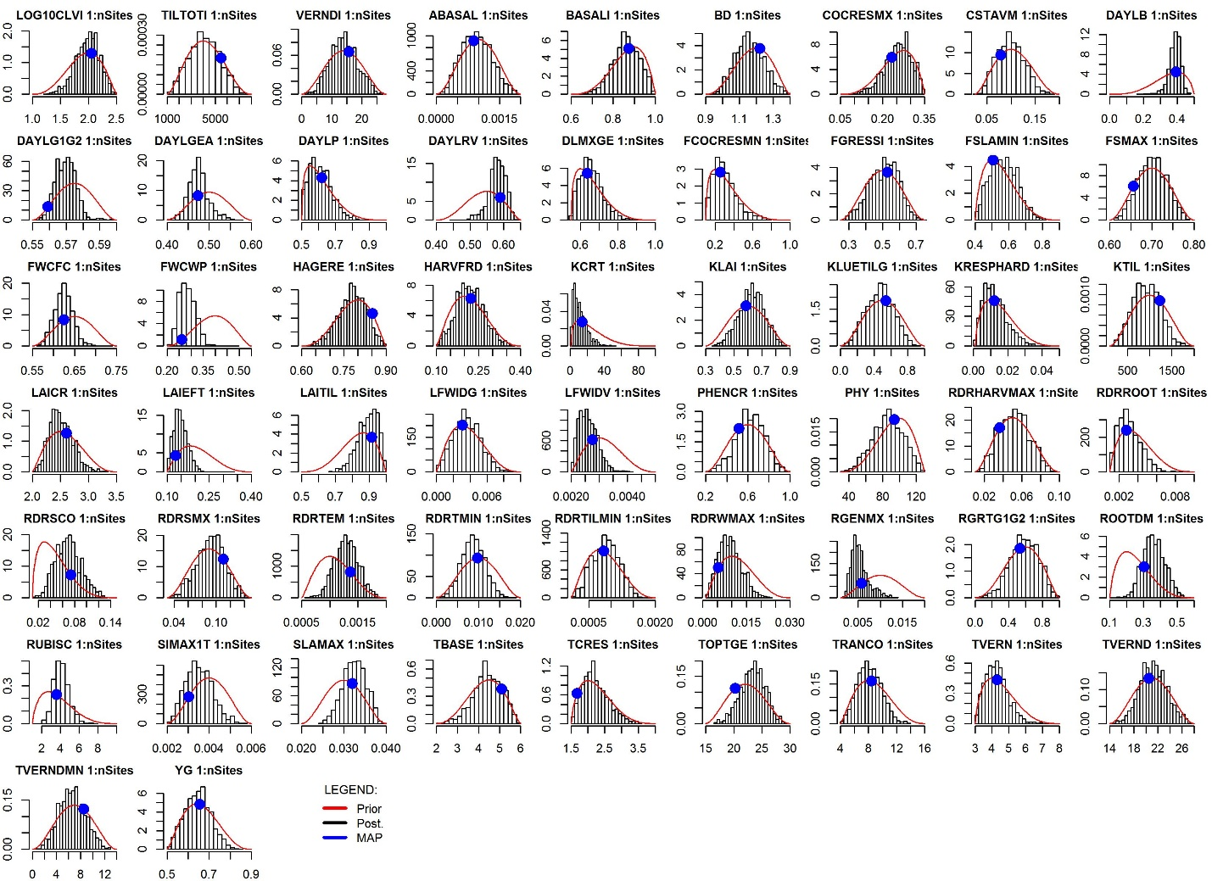

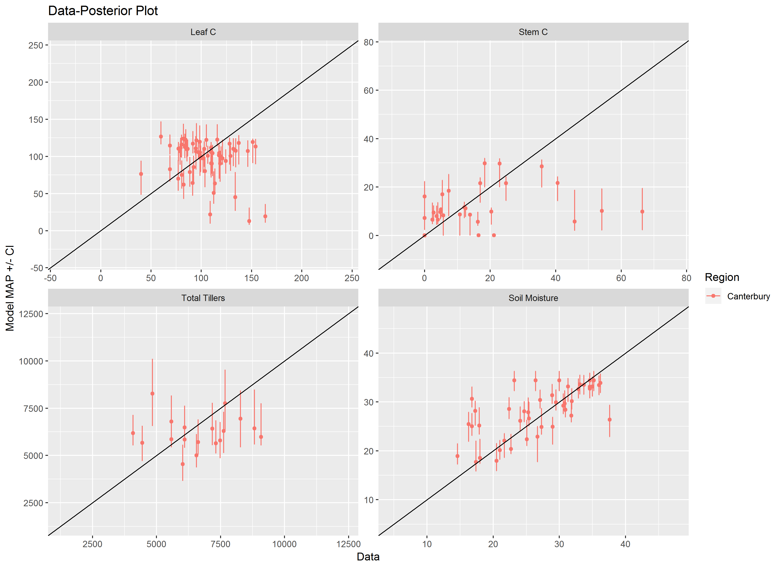

Note:

If we add the non-parameter error, we should touch the 1:1 line ~95% of the time? Errors are currently

err_c <- c(TILTOT=1000, CLV=40, CST=5, WCLM=5, BASAL=10)

# Waikato

runMCMC terminated after 460.660000000003seconds

96000 . Current logp -699.4639 -695.3317 -694.1158 Please wait! runMCMC terminated after 447.139999999999seconds

96000 . Current logp -699.7445 -693.804 -699.6296 Please wait! runMCMC terminated after 444.550000000003seconds

96000 . Current logp -688.6582 -695.9597 -689.4851 Please wait!

Total chains = 9

Total samples per chain = 16000

Overall convergence (mpsrf) = 1.524

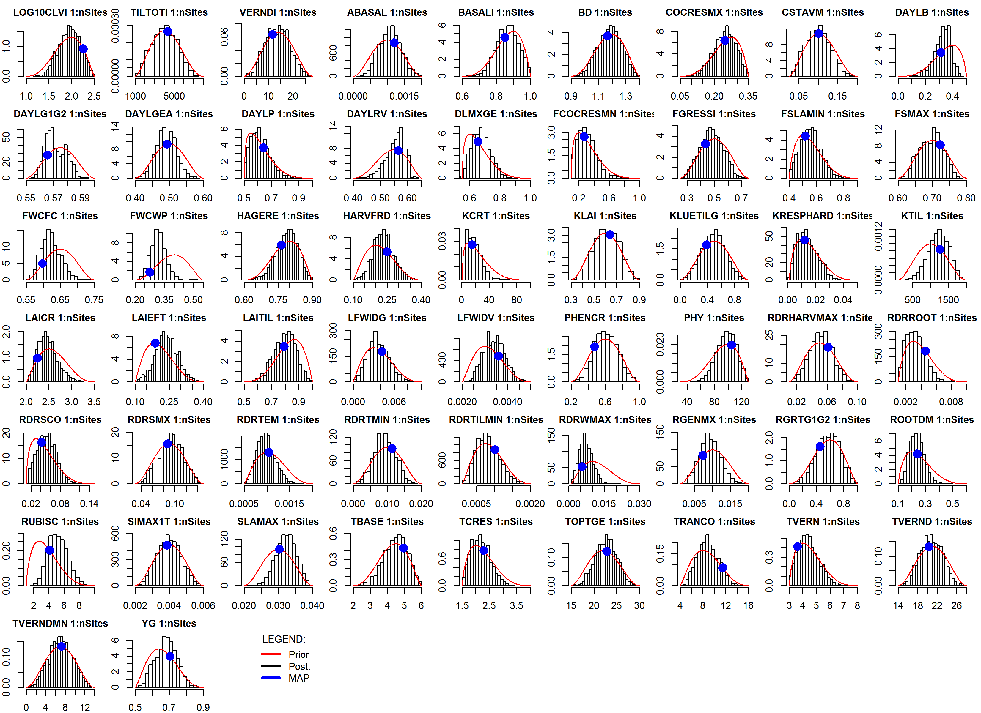

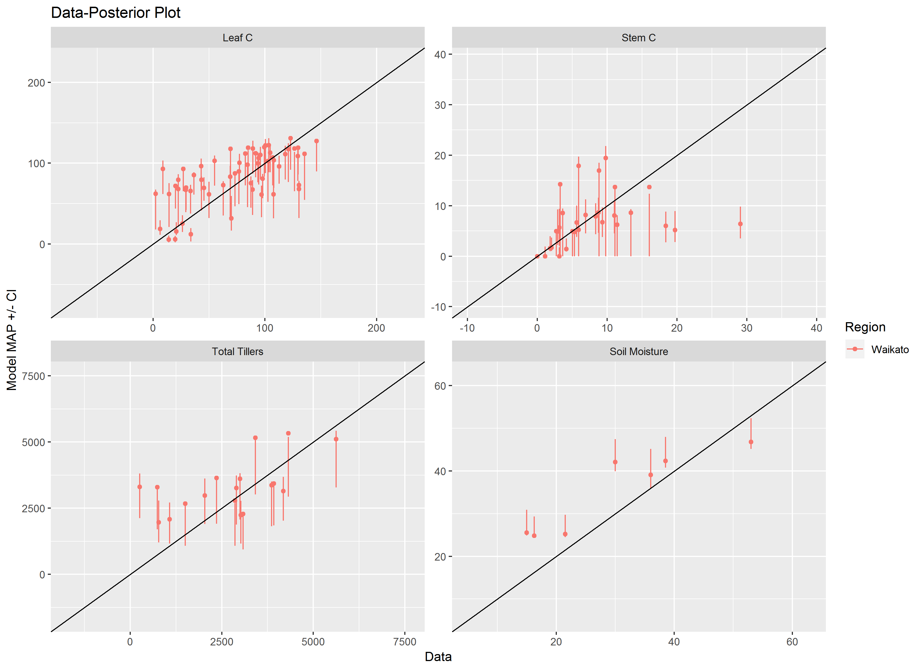

# Northland

runMCMC terminated after 434.639999999999seconds

96000 . Current logp -745.114 -752.7929 -745.7807 Please wait! runMCMC terminated after 475.529999999999seconds

96000 . Current logp -744.8134 -744.9612 -739.4294 Please wait! runMCMC terminated after 447.630000000005seconds

96000 . Current logp -753.7781 -744.6656 -742.1016 Please wait!

Total chains = 9

Total samples per chain = 16000

Overall convergence (mpsrf) = 2.127

